Oval

Definition
# Source: AI Source: Provided by: [Data Path: Persons Table -> ID Column: 1, Name_En Column: Motasem Essam] -> From: [ChatGPT] on [7/25/2026]
An oval is a closed, smooth, rounded plane shape that is generally longer in one direction than the other.
Unlike a circle, an oval does not necessarily have all points at the same distance from a single center. Unlike an ellipse, oval is a broad geometric description rather than one specific mathematical curve.
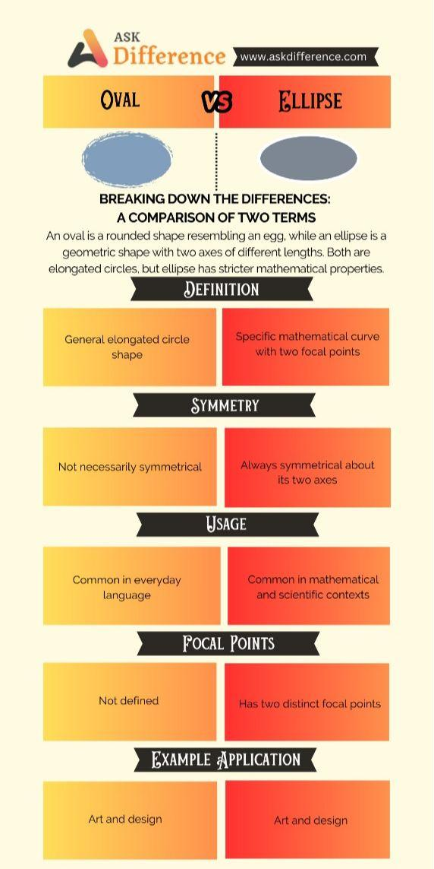
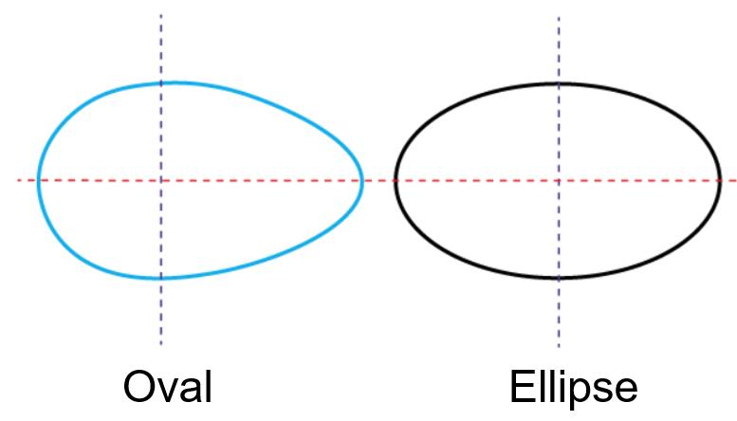
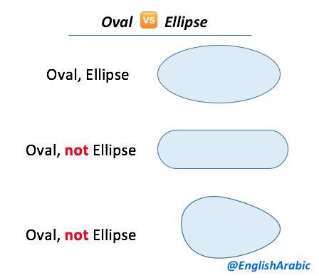

Fundamental Concept
# Source: AI Source: Provided by: [Data Path: Persons Table -> ID Column: 1, Name_En Column: Motasem Essam] -> From: [ChatGPT] on [7/25/2026]
An oval generally has:
- A closed boundary
- A smooth, continuous curve
- A rounded appearance
- A longer dimension and a shorter dimension
- Usually two approximately opposite ends
- No corners or straight-line vertices
A typical oval resembles a stretched circle.

Oval vs. Ellipse
# Source: AI Source: Provided by: [Data Path: Persons Table -> ID Column: 1, Name_En Column: Motasem Essam] -> From: [ChatGPT] on [7/25/2026]
The terms oval and ellipse are sometimes used interchangeably in everyday language, but they are not mathematically identical.
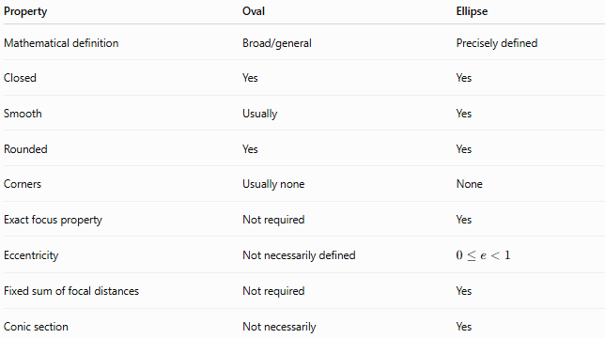
Property | Oval | Ellipse
Mathematical definition | Broad/general | Precisely defined
Closed | Yes | Yes
Smooth | Usually | Yes
Rounded | Yes | Yes
Corners | Usually none | None
Exact focus property | Not required | Yes
Eccentricity | Not necessarily defined | $$0≤e<1$$
Fixed sum of focal distances | Not required | Yes
Conic section | Not necessarily | Yes
Therefore:
$$\boxed{\text{Every ellipse is an oval-like shape, but not every oval is an ellipse.}}$$

Oval Classification
# Source: AI Source: Provided by: [Data Path: Persons Table -> ID Column: 1, Name_En Column: Motasem Essam] -> From: [ChatGPT] on [7/25/2026]
Because oval is a broad shape category, it can include several mathematical constructions.
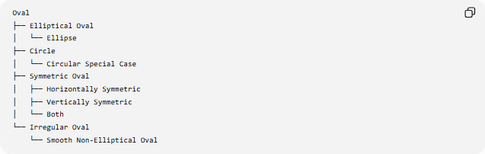
Oval
├── Elliptical Oval
│ └── Ellipse
├── Circle
│ └── Circular Special Case
├── Symmetric Oval
│ ├── Horizontally Symmetric
│ ├── Vertically Symmetric
│ └── Both
└── Irregular Oval
└── Smooth Non-Elliptical Oval
A circle can be regarded as a special case of an ellipse and is also commonly described as an oval in ordinary language.

Common Types of Oval Shapes

1. Elliptical Oval
# Source: AI Source: Provided by: [Data Path: Persons Table -> ID Column: 1, Name_En Column: Motasem Essam] -> From: [ChatGPT] on [7/25/2026]
An elliptical oval is an oval whose mathematical boundary is an ellipse.
Its standard equation can be:
$$\boxed{\frac{x^{2}}{a^{2}}+\frac{y^{2}}{b^{2}}=1}$$
when centered at the origin.
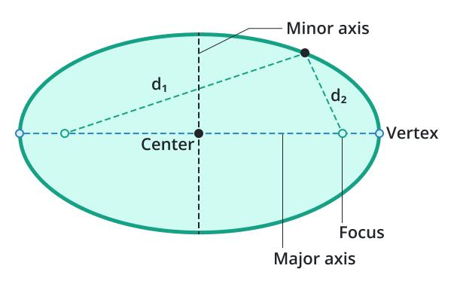
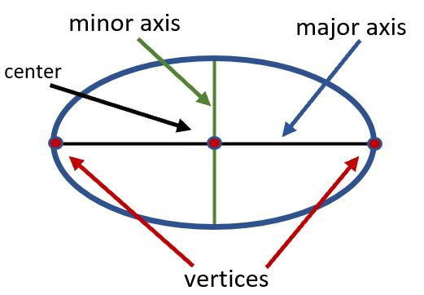
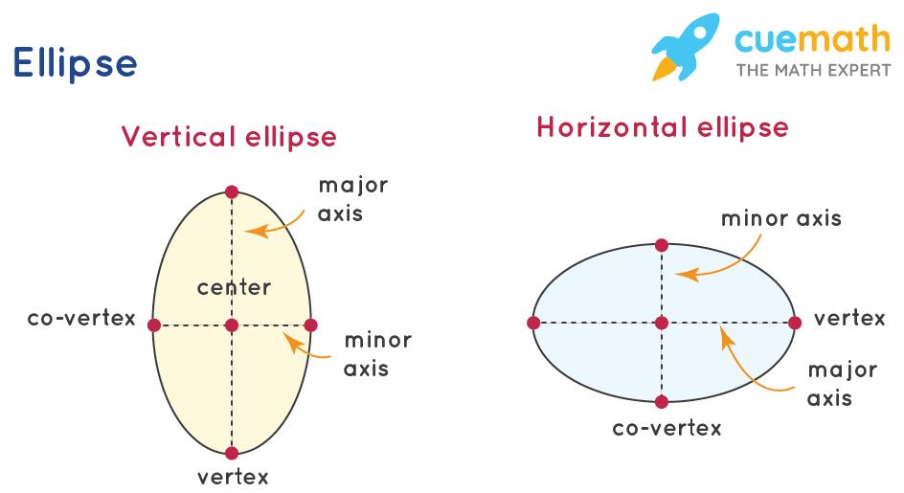
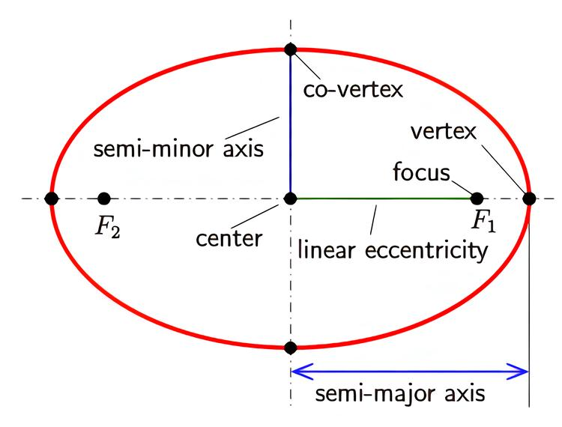

2. Symmetric Oval
# Source: AI Source: Provided by: [Data Path: Persons Table -> ID Column: 1, Name_En Column: Motasem Essam] -> From: [ChatGPT] on [7/25/2026]
A symmetric oval has one or more axes of symmetry.
For example, an ellipse has two perpendicular symmetry axes.
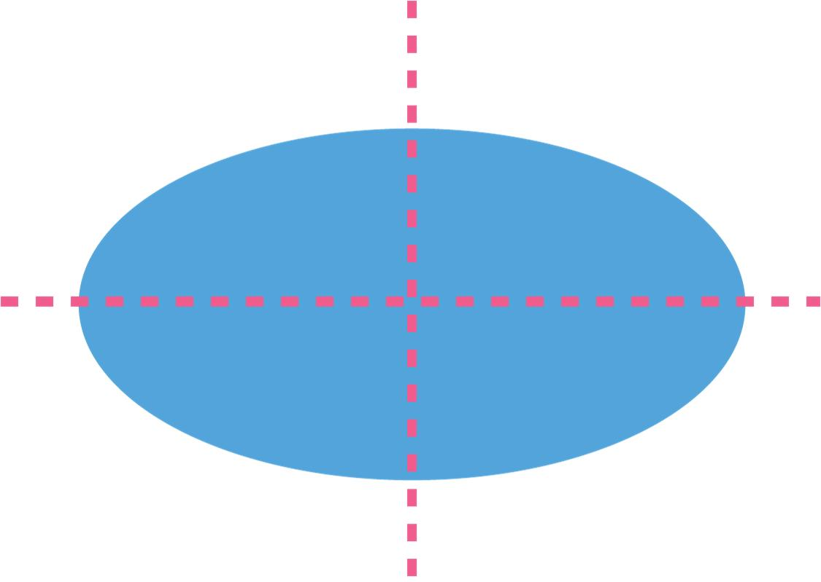
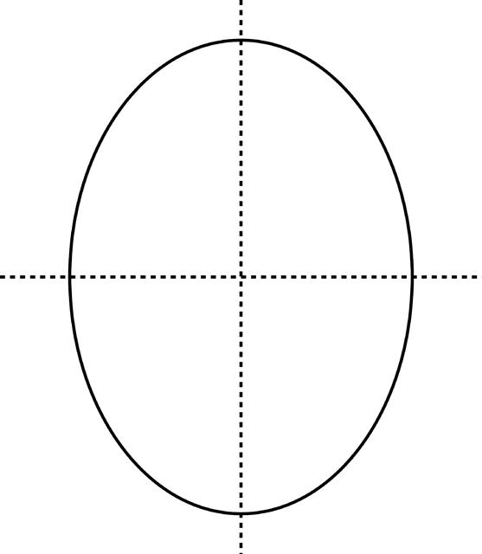
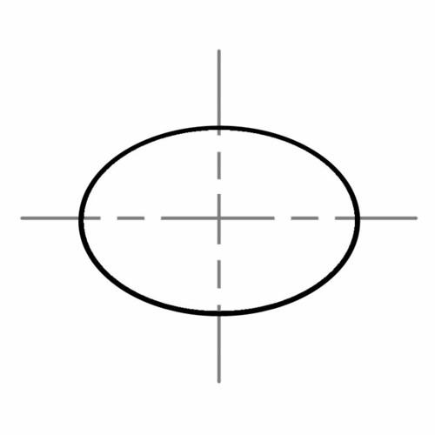
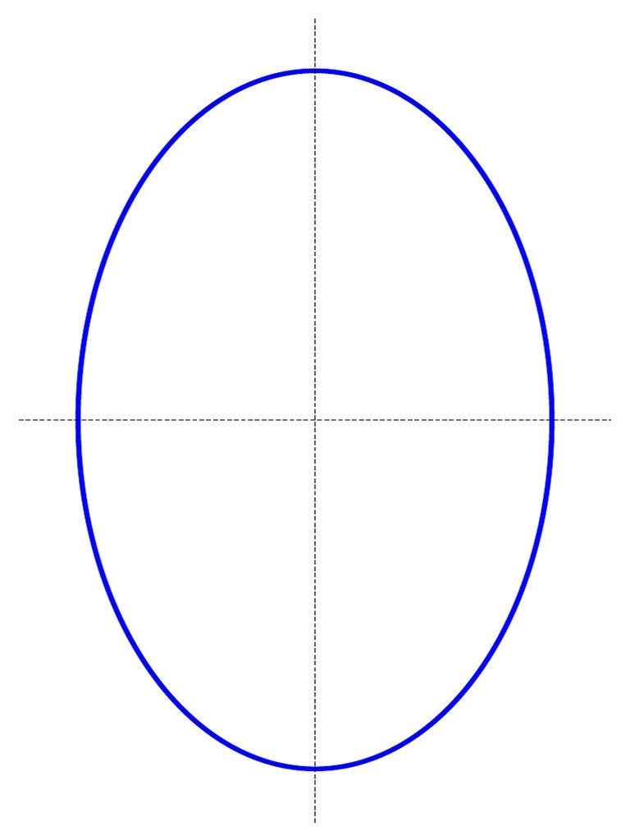

3. Irregular Oval
# Source: AI Source: Provided by: [Data Path: Persons Table -> ID Column: 1, Name_En Column: Motasem Essam] -> From: [ChatGPT] on [7/25/2026]
An irregular oval is a smooth closed rounded shape that does not necessarily follow the equation of an ellipse.
It may be constructed using different curves or combinations of curves.
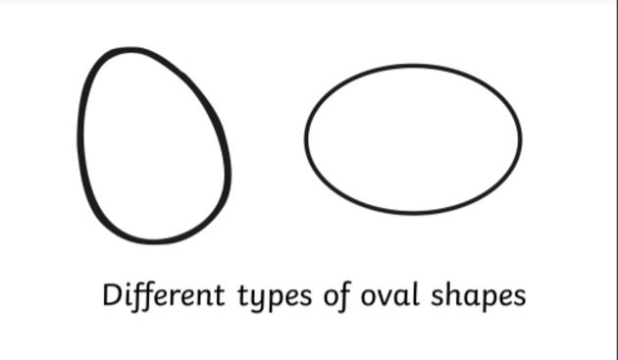
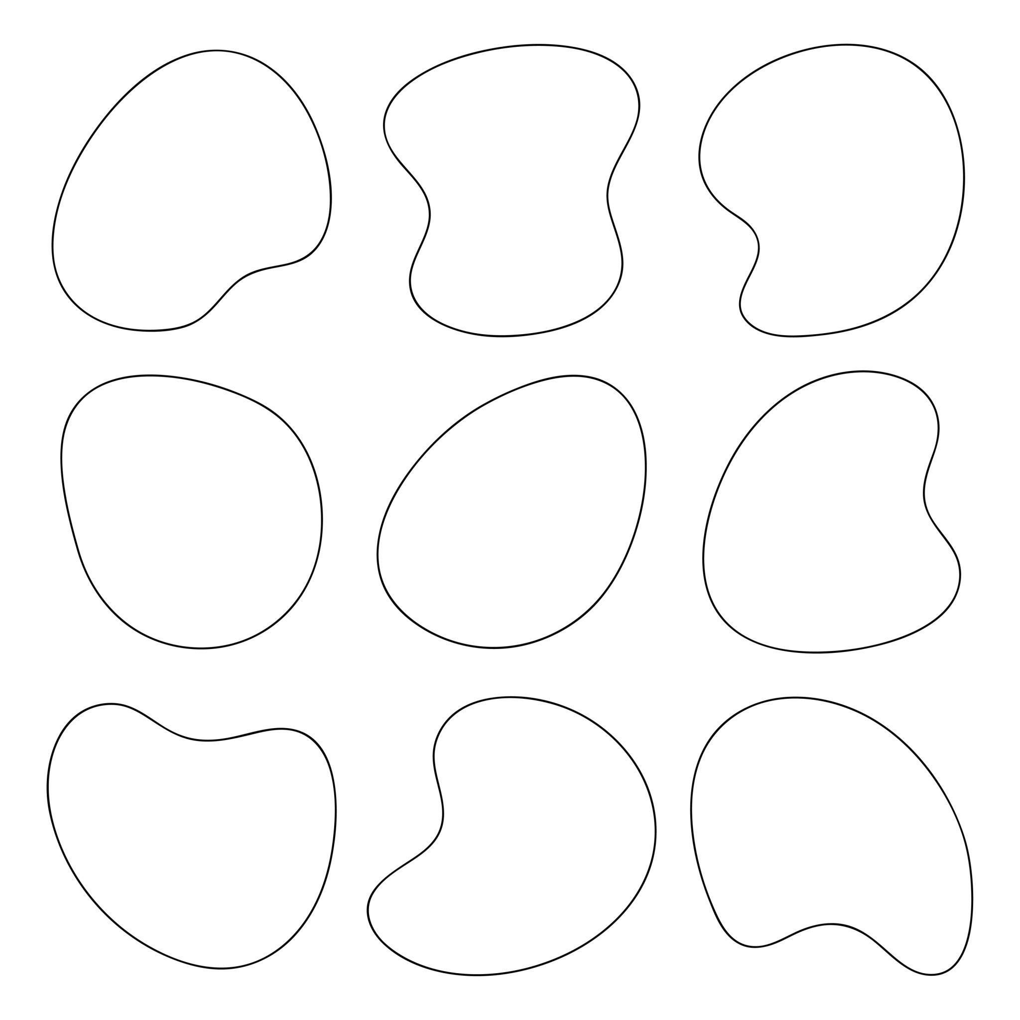
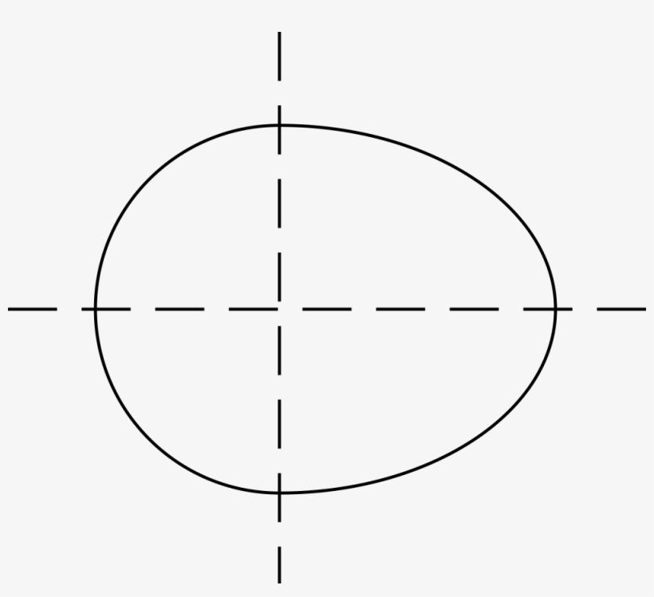
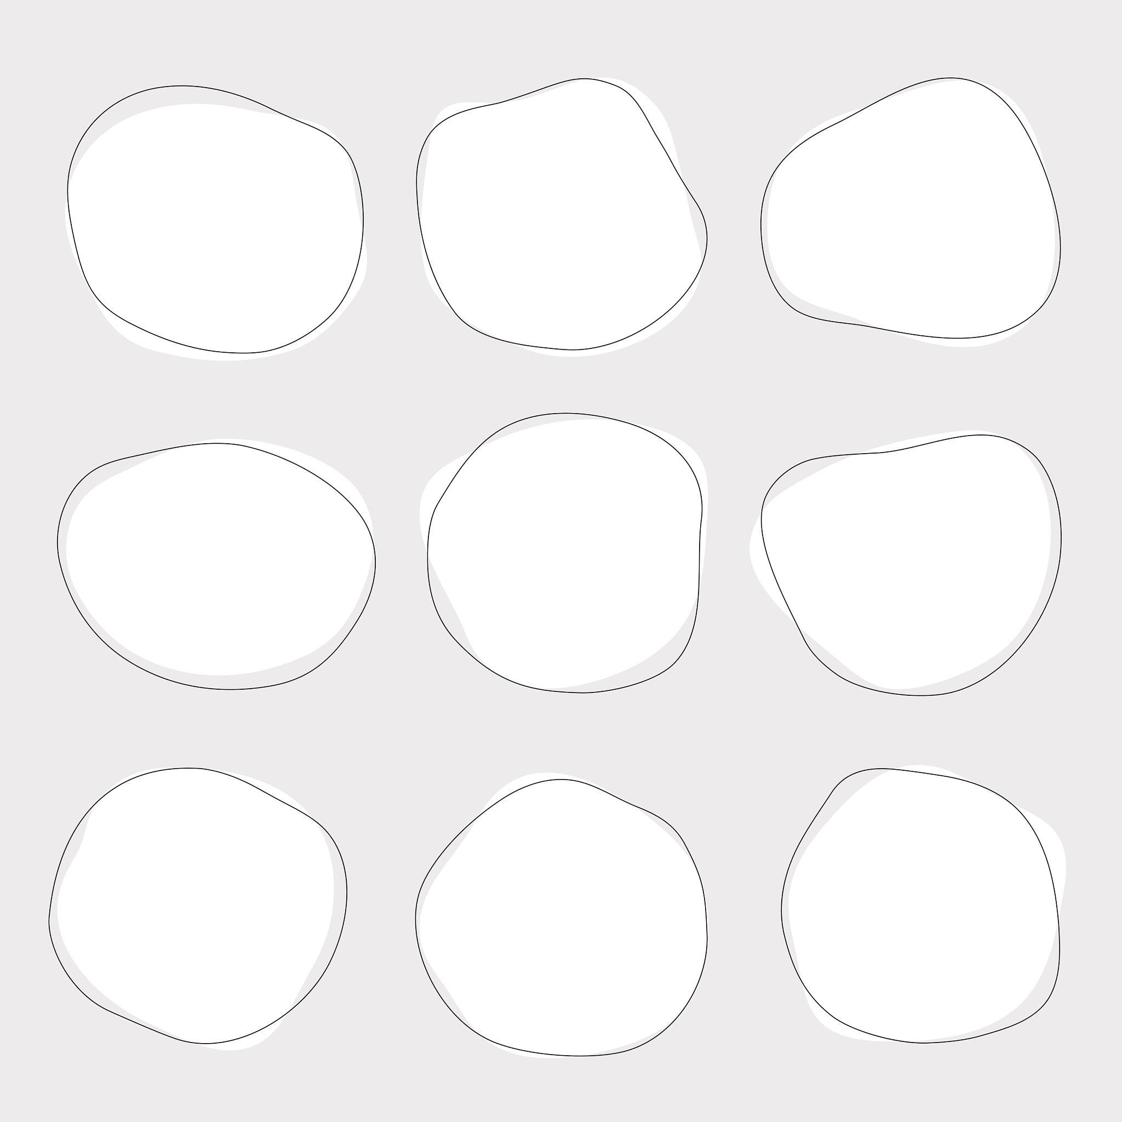

Dimensions of an Oval
# Source: AI Source: Provided by: [Data Path: Persons Table -> ID Column: 1, Name_En Column: Motasem Essam] -> From: [ChatGPT] on [7/25/2026]
Although an oval does not have a universal mathematical definition, an oval-like shape can commonly be described using:
Major Dimension
The major dimension is the longest distance across the oval.
For an ellipse, this corresponds to the major axis:
$$\boxed{2a}$$
Minor Dimension
The minor dimension is the shortest distance across the oval.
For an ellipse:
$$\boxed{2b}$$
Thus, for an elliptical oval:
$$\boxed{\text{Major Axis}=2a} \\ \boxed{\text{Minor Axis}=2b}$$

Symmetry
# Source: AI Source: Provided by: [Data Path: Persons Table -> ID Column: 1, Name_En Column: Motasem Essam] -> From: [ChatGPT] on [7/25/2026]
Many ovals have:
- One axis of symmetry, or
- Two axes of symmetry.
A standard ellipse has:
$$\boxed{2\text{ lines of reflection symmetry}}$$
and rotational symmetry of order:
$$\boxed{2}$$
However, an arbitrary oval does not necessarily have any symmetry.

Mathematical Representation
# Source: AI Source: Provided by: [Data Path: Persons Table -> ID Column: 1, Name_En Column: Motasem Essam] -> From: [ChatGPT] on [7/25/2026]
There is no single universal equation for an oval.
For an elliptical oval, the equation may be:
$$\boxed{\frac{{\left(x-h\right)}^{2}}{a^{2}}+\frac{{\left(y-k\right)}^{2}}{b^{2}}=1}$$
For other oval shapes, different equations can be used.
This is an important distinction:
$$\boxed{\text{Oval is a shape category, not one specific mathematical curve.}}$$

Area
# Source: AI Source: Provided by: [Data Path: Persons Table -> ID Column: 1, Name_En Column: Motasem Essam] -> From: [ChatGPT] on [7/25/2026]
There is no universal area formula for every oval because different oval shapes can have different mathematical boundaries.
For an elliptical oval, however:
$$\boxed{A=πab}$$
where:
- $a$= semi-major axis
- $b$= semi-minor axis.

Perimeter
# Source: AI Source: Provided by: [Data Path: Persons Table -> ID Column: 1, Name_En Column: Motasem Essam] -> From: [ChatGPT] on [7/25/2026]
There is also no universal perimeter formula for an arbitrary oval.
For an elliptical oval, the perimeter is generally calculated using approximations because an ellipse does not have a simple elementary exact perimeter formula.
One common approximation is:
$$\boxed{P≈π\left[3\left(a+b\right)-\sqrt{\left(3a+b\right)\left(a+3b\right)}\right]}$$

Oval and Eccentricity
# Source: AI Source: Provided by: [Data Path: Persons Table -> ID Column: 1, Name_En Column: Motasem Essam] -> From: [ChatGPT] on [7/25/2026]
Because oval is not one specific mathematical curve, it does not have one universal eccentricity.
If the oval is specifically an ellipse, then its eccentricity is:
$$\boxed{e=\frac{c}{a}}$$
with:
$$\boxed{0≤e<1}$$
A circular oval has:
$$\boxed{e=0}$$
A non-circular elliptical oval has:
$$\boxed{0<e<1}$$
An arbitrary non-elliptical oval does not necessarily have a meaningful conic eccentricity.

Oval vs. Circle
# Source: AI Source: Provided by: [Data Path: Persons Table -> ID Column: 1, Name_En Column: Motasem Essam] -> From: [ChatGPT] on [7/25/2026]
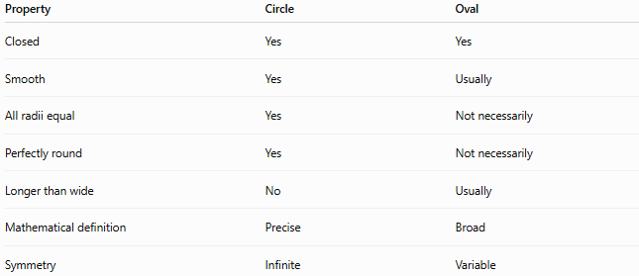
Property | Circle | Oval
Closed | Yes | Yes
Smooth | Yes | Usually
All radii equal | Yes | Not necessarily
Perfectly round | Yes | Not necessarily
Longer than wide | No | Usually
Mathematical definition | Precise | Broad
Symmetry | Infinite | Variable

Oval vs. Other Conic Sections
# Source: AI Source: Provided by: [Data Path: Persons Table -> ID Column: 1, Name_En Column: Motasem Essam] -> From: [ChatGPT] on [7/25/2026]
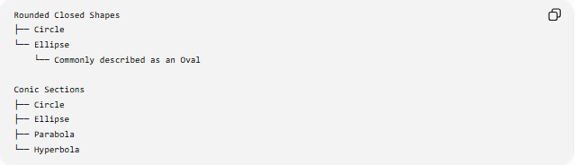
Rounded Closed Shapes
├── Circle
└── Ellipse
└── Commonly described as an Oval

Conic Sections
├── Circle
├── Ellipse
├── Parabola
└── Hyperbola
An oval should not normally be placed alongside circle, ellipse, parabola, and hyperbola as if all five were equivalent mathematical conic-section types.
A more precise classification is:
$$\boxed{\text{Oval}→\text{General Shape Category}}$$
while:
$$\boxed{\text{Ellipse}→\text{Specific Mathematical Curve}}$$

Real-World Examples
# Source: AI Source: Provided by: [Data Path: Persons Table -> ID Column: 1, Name_En Column: Motasem Essam] -> From: [ChatGPT] on [7/25/2026]
Oval shapes appear in:
- Eggs
- Oval mirrors
- Oval tables
- Running tracks
- Sports fields
- Stadium designs
- Decorative frames
- Certain lenses
- Architectural openings
- Logos and symbols
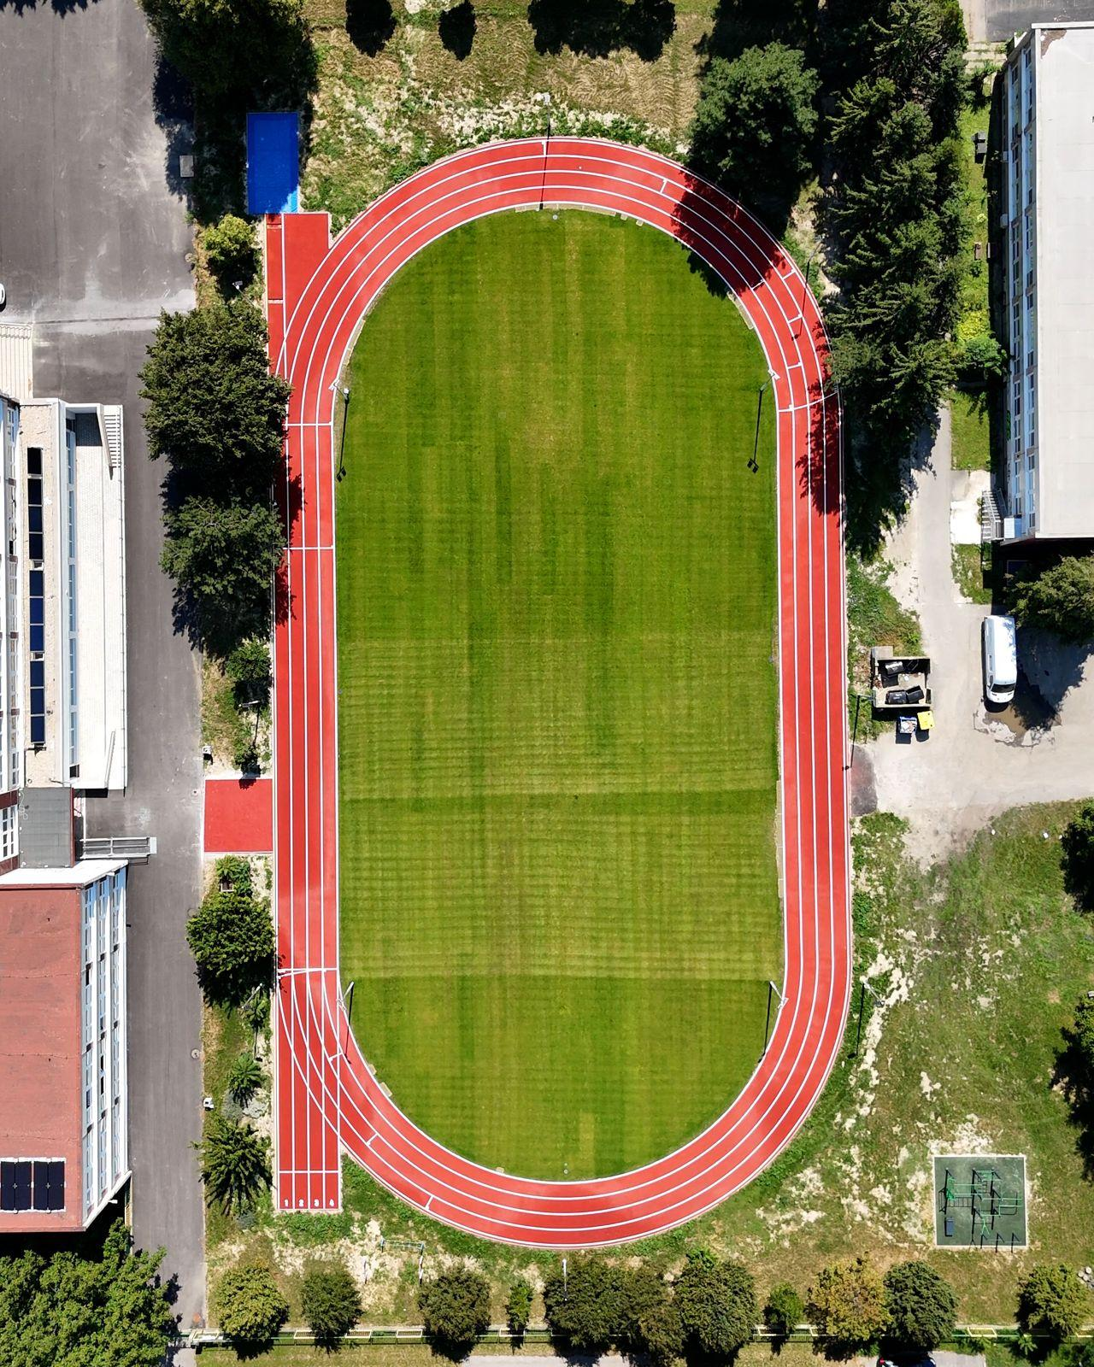
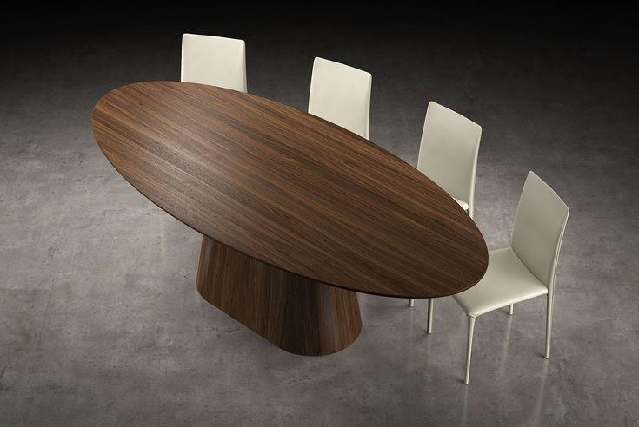
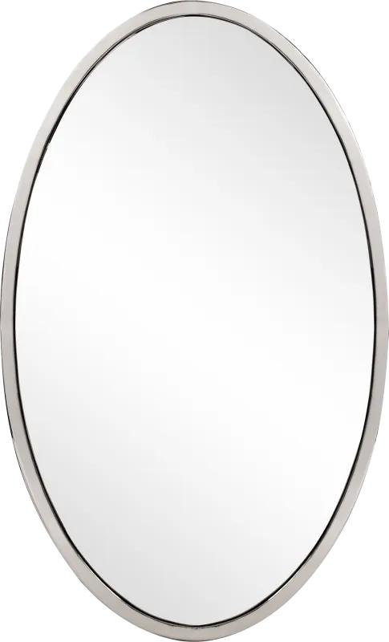
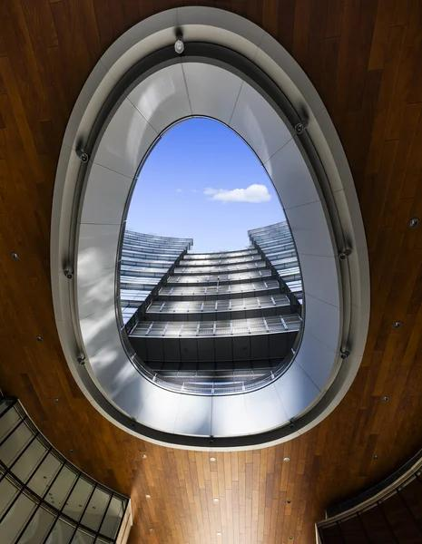
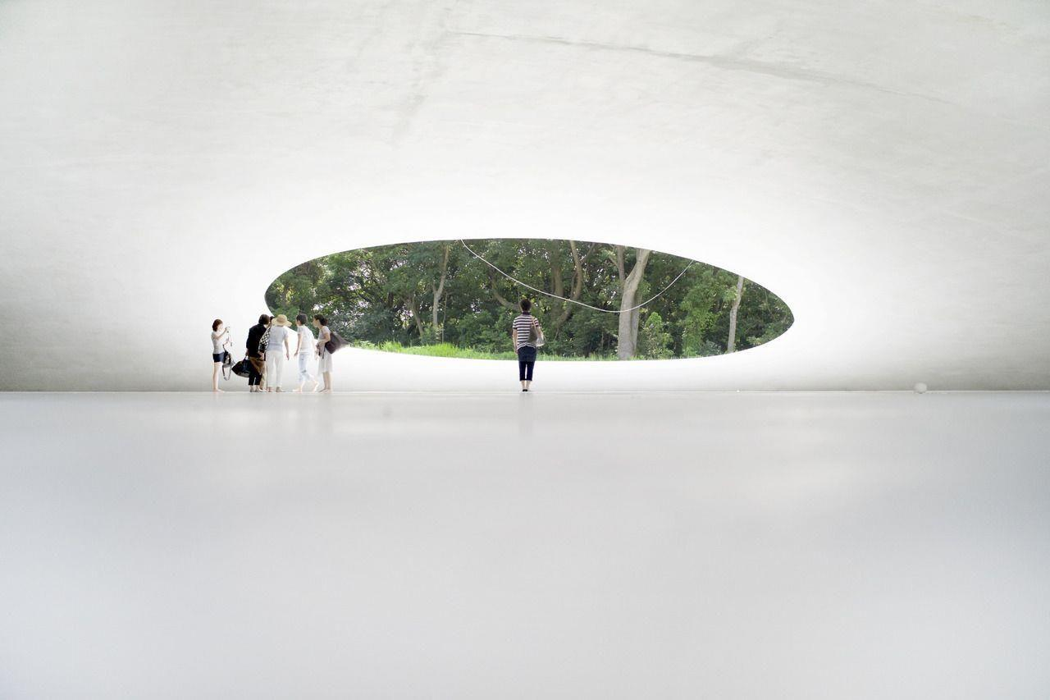

Key Points
# Source: AI Source: Provided by: [Data Path: Persons Table -> ID Column: 1, Name_En Column: Motasem Essam] -> From: [ChatGPT] on [7/25/2026]
- An oval is a broad term for a closed, smooth, rounded shape.
- It is usually longer in one direction than the other.
- There is no single universal mathematical equation for every oval.
- An ellipse is a specific mathematical curve that commonly has an oval shape.
- A circle is a special case of an ellipse and can also be called an oval in everyday usage.
- An arbitrary oval does not necessarily have a focus, directrix, or eccentricity.
- For an elliptical oval:
$$\boxed{A=πab}$$
and:
$$\boxed{0≤e<1}$$

Conclusion
# Source: AI Source: Provided by: [Data Path: Persons Table -> ID Column: 1, Name_En Column: Motasem Essam] -> From: [ChatGPT] on [7/25/2026]
An oval is best understood as a general geometric shape category rather than a single precisely defined curve. It describes closed, smooth, rounded shapes that are typically elongated.
The most important distinction is:
$$\boxed{\text{Oval = broad shape description}} \\ \boxed{\text{Ellipse = specific mathematical curve}}$$
Therefore, in a formal mathematics knowledge taxonomy, Ellipse should be treated as a mathematical curve/conic section, while Oval is better treated as a broader geometric shape that may include elliptical and non-elliptical forms.

